**DESIGNING AND IMPLEMENTING A CUSTOM VPC**

**Ex.No : 04 Name : S.Yuvasri**

**Date: Roll.No: 23MCA039**

**AIM:**

To create a new Virtual Private Cloud(VPC) in AWS and perform the following

* Create a new VPC with a custom subnet.
* Configure security groups for the subnet.
* Create a gateway and set up a routing table.
* Implement a public and a private subnet within the VPC.
* Enable internet access for the public subnet and configure a NAT gateway to provide internet access to the private subnet.

**THEORATICAL BACKGROUND:**

**VPC**

A virtual private cloud (VPC) is a secure, isolated private cloud hosted within a public cloud. VPC customers can run code, store data, host websites, and do anything else they could do in an ordinary private cloud, but the private cloud is hosted remotely by a public cloud provider. (Not all private clouds are hosted in this fashion.) VPCs combine the scalability and convenience of public cloud computing with the data isolation of private cloud computing.

**Subnet**

A subnet is a smaller portion of the network that typically includes all the machines in a certain area. We can add as many as subnets we need in one availability zone. Each subnet must reside entirely within one availability zone. The public subnets will be attached to Internet Gateway which enables Internet access. The private subnets will not have internet access. Each and every subnet which is presented in VPC must be associated with the routing table.

**Internet Gateway**

With the help of IGW (Internet Gateway), the resources present (e.g: EC2) in the VPC will enable to access the Internet. One VPC can’t have more than one IGW .If resources are running in a certain VPC then IGW can not be detached from that particular VPC.

**Route Table**

Route Table contains a set of rules, called route which helps us to route the network traffic. A single VPC can have as many as route tables it requires. If the dependencies are attached to the route table then they can’t be deleted.

**NAT Gateway**

Network Address Translation (NAT) is a process in which one or more local IP address is translated into one or more Global IP address and vice versa in order to provide Internet access to the local hosts. Also, it does the translation of port numbers i.e. masks the port number of the host with another port number, in the packet that will be routed to the destination. It then makes the corresponding entries of IP address and port number in the NAT table. NAT generally operates on a router or firewall.

**STEPS INVOLVED:**

**1)Create a new VPC with a custom subnet.**

**Step 1:** To create a new VPC go to VPC 🡪 Create a new VPC .And give name of the vpc and give IPV4 code for vpc “10.0.0.0/16”

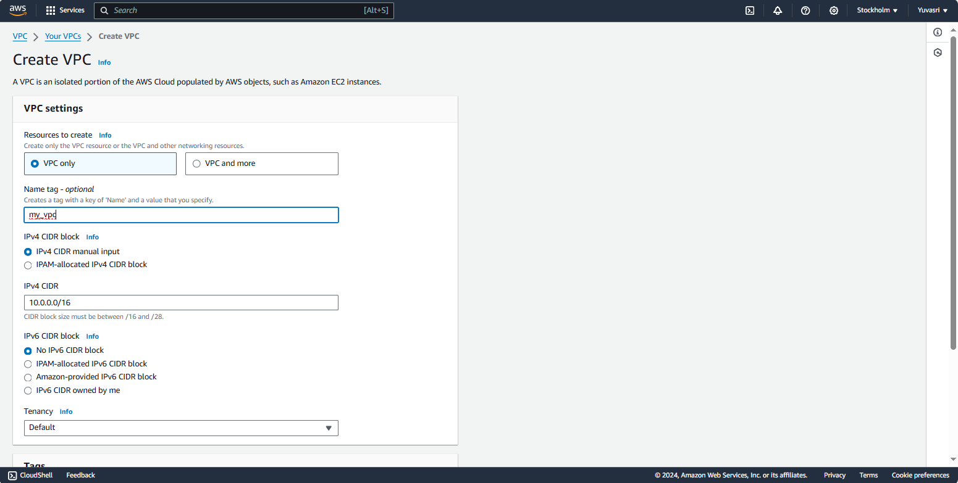

**Step 2:** After creating the VPC create two subnets one is for public and other for private. For creating subnet go to subnet and click create subnet. For Public subnet choose our vpc and give name for the subnet. In the IPV4 subnet block “10.0.0.1/20” and click “create subnet”. For private subnet in the IPV4 subnet block “10.0.16.0/20”

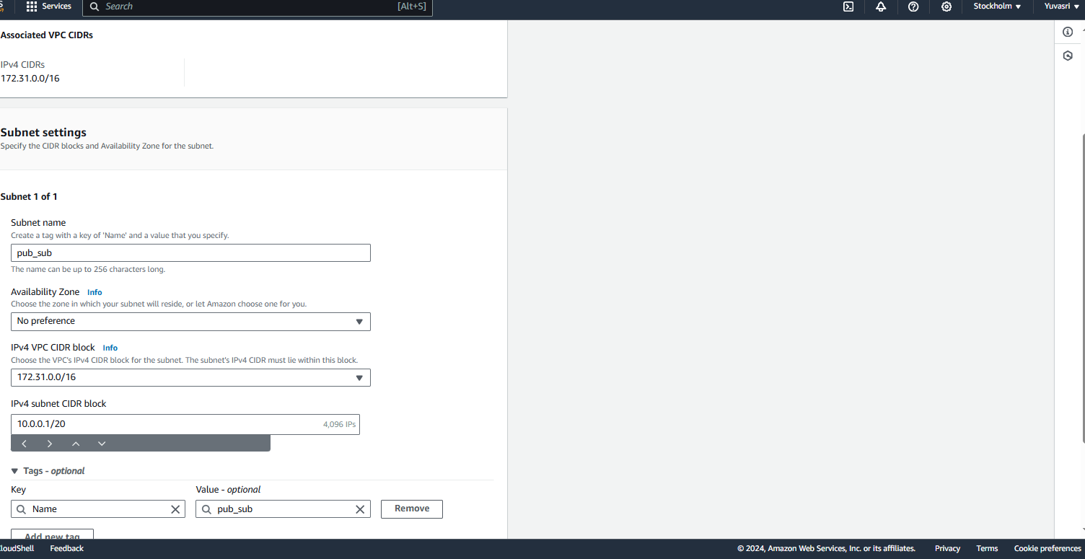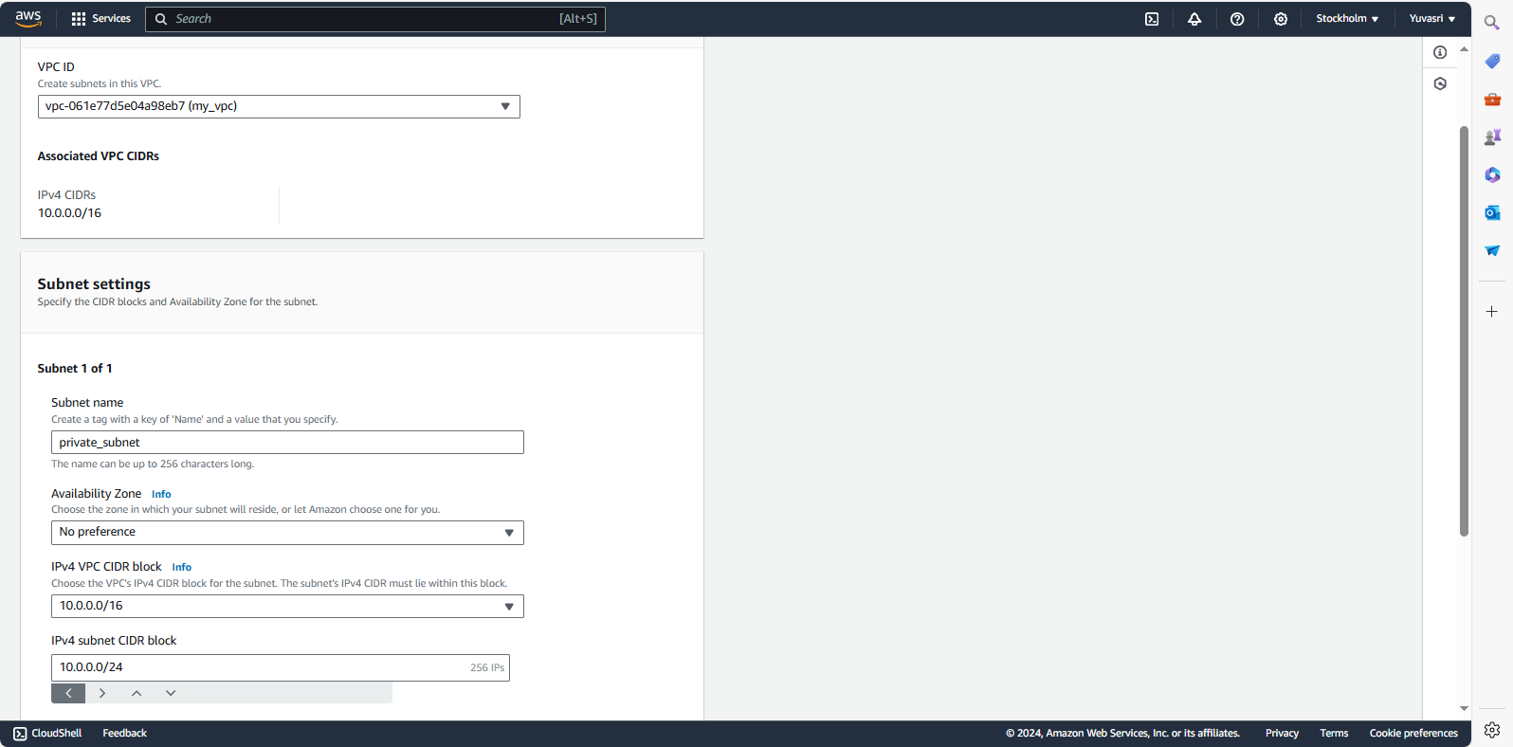

**Step 3:** Finally,the subnets are created for our VPC.

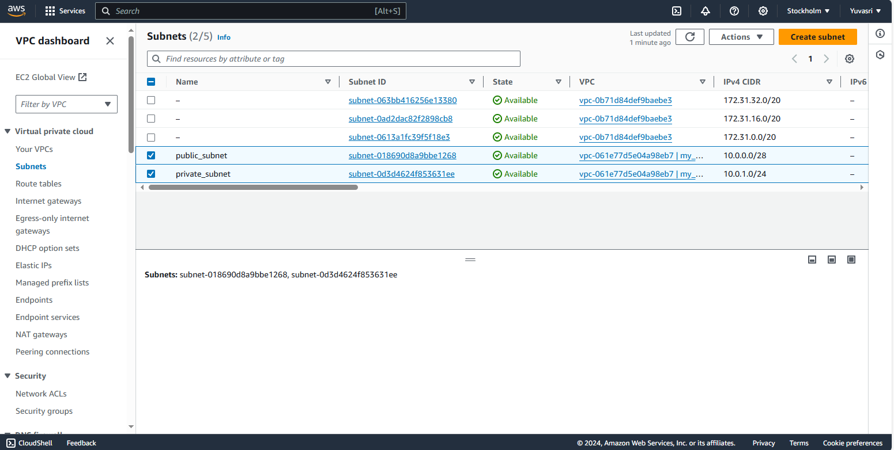

**2) Configure security groups for the subnet.**

**Step 1:** Two security groups were created for the subnets .Create a security group for public go to Create security group and give name to the security group. Choose our VPC and add inbound rules such as HTTP, SSH. RDP, ALL TCP with anywhere IP4 and click “Create Security group”

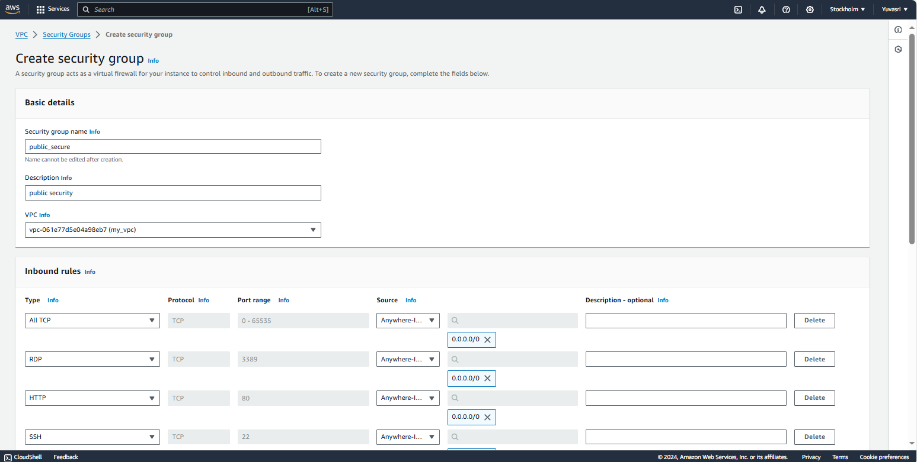

**Step 2:** For private security group add inbound rule choose “All TCP” and choose IPV4 address as custom and give public subnet IP “10.0.0.0/20” and click create.

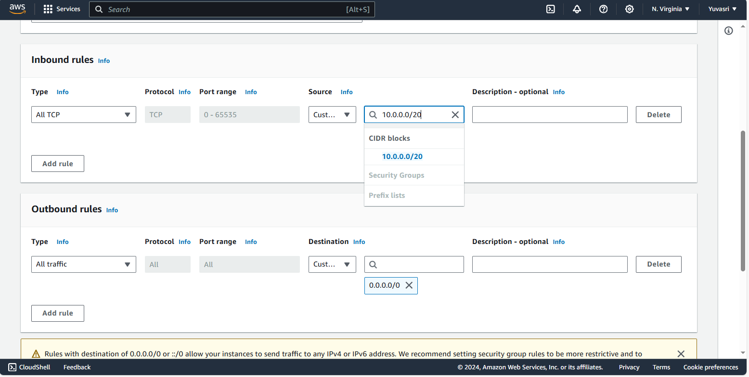

**Step 3:** Two security groups were created for public and private and it have an IP address of the public subnet.

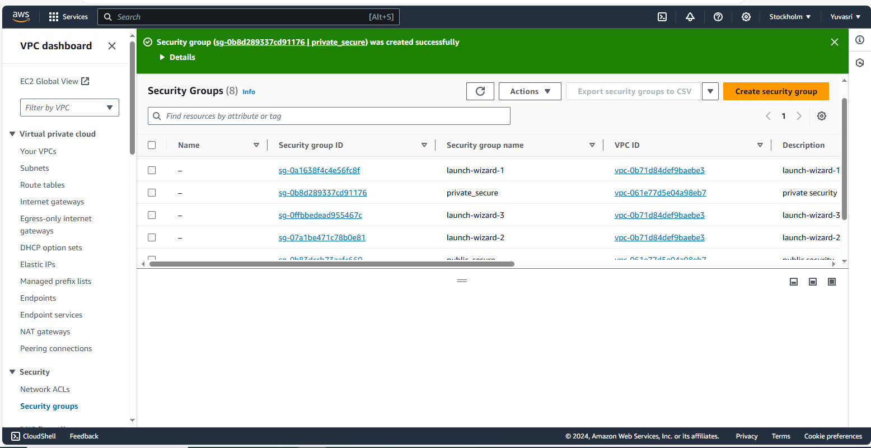

**3) Create a gateway and set up a routing table.**

**Step 1:** Create a internet gateway to provide internet for the instances. Go to create internet gateway and give name to the internet gateway and click create.

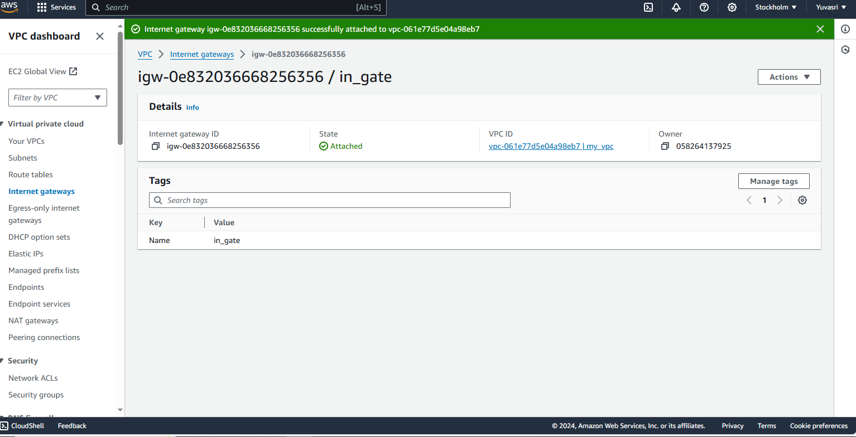

**Step 2:** Create two routing table for public and private. For public and private route table give name and choose VPC.

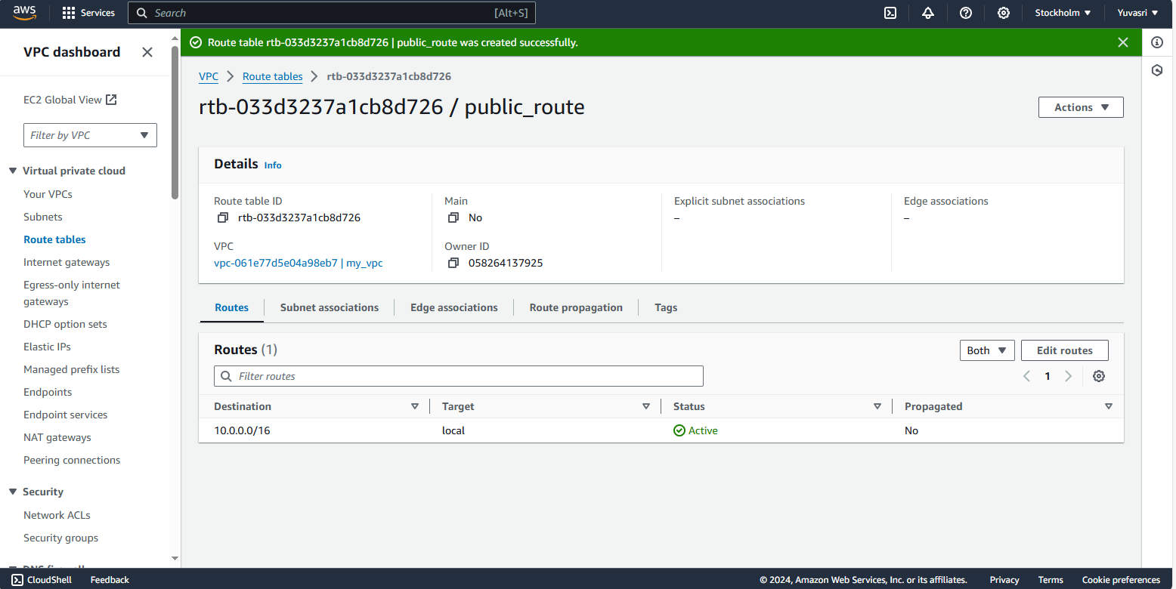  
**Step 3:** Click Edit subnet associations for both public and private route table. For public route table select public subnet and for private route table select private subnet.

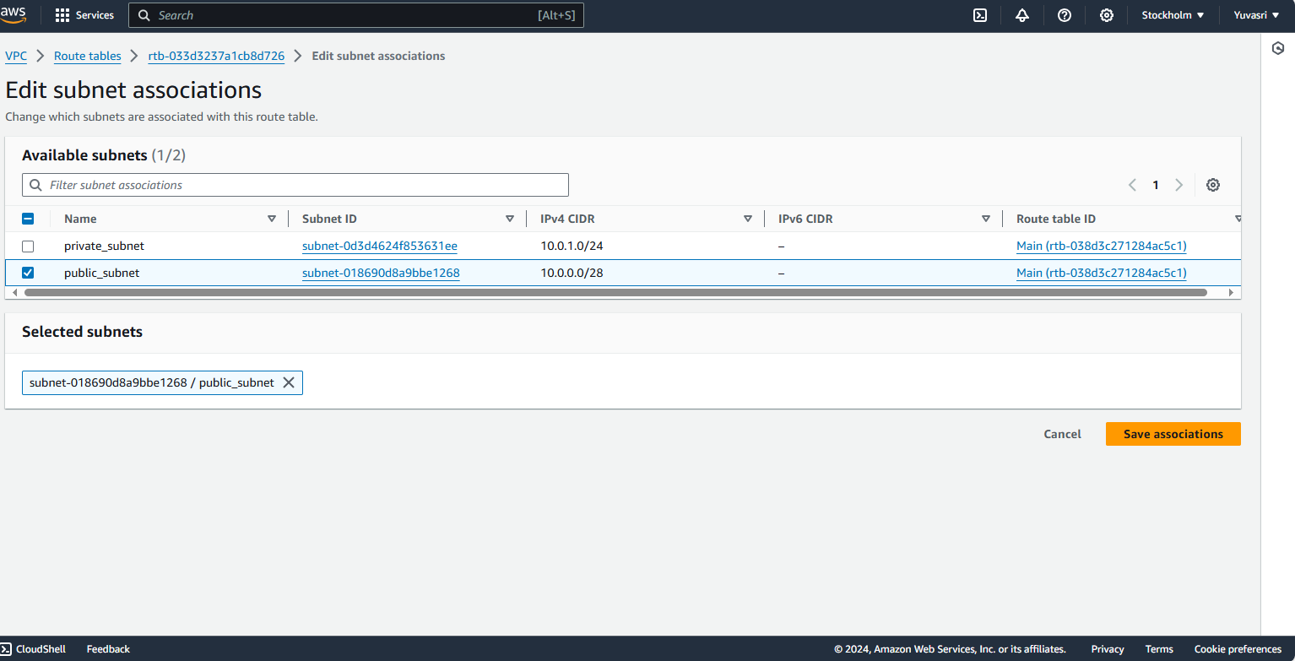

**Step 4:** For public route table got to routes and click “Edit routes” and give internet gateway rule for providing internet to the public instances.

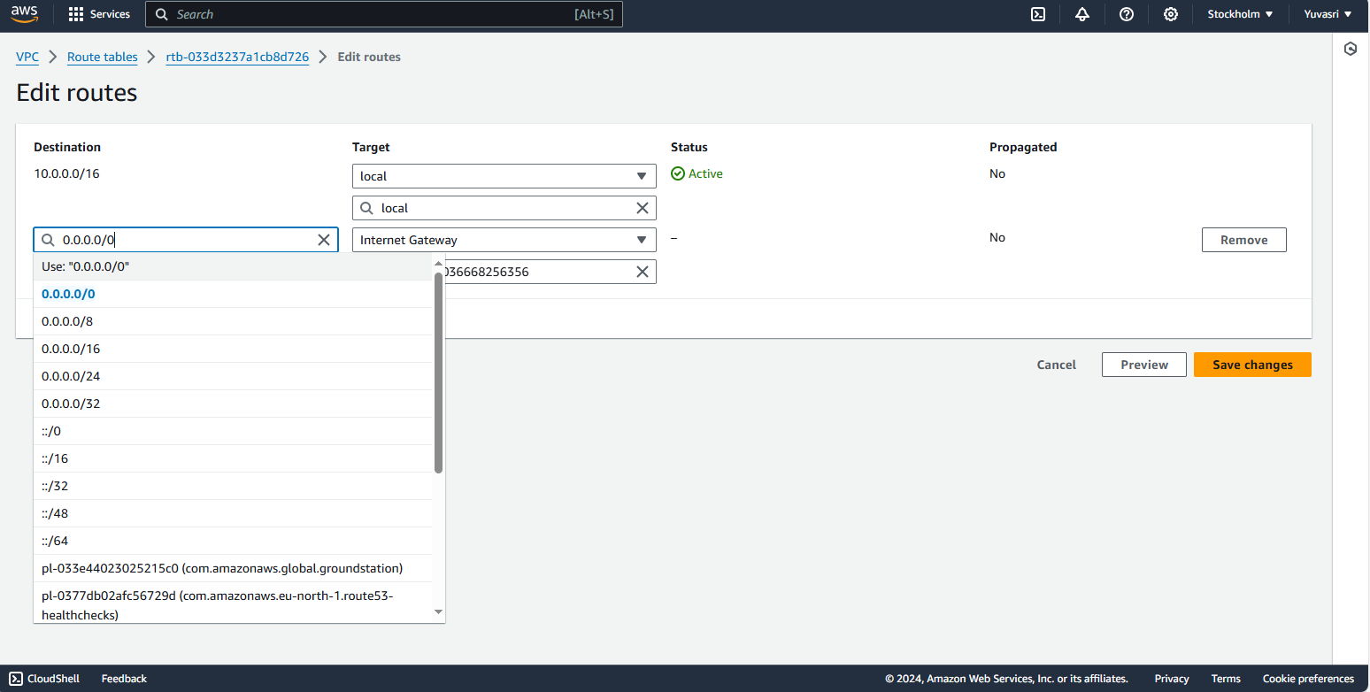

**4) Implement a public and a private instances within the VPC.**

**Step 1**: Create two instances public and private.In the public instance creation edit “Network settings” and choose our VPC and select public subnet and enable the auto assign IP address and select existing security group and click public security group and click launch instances

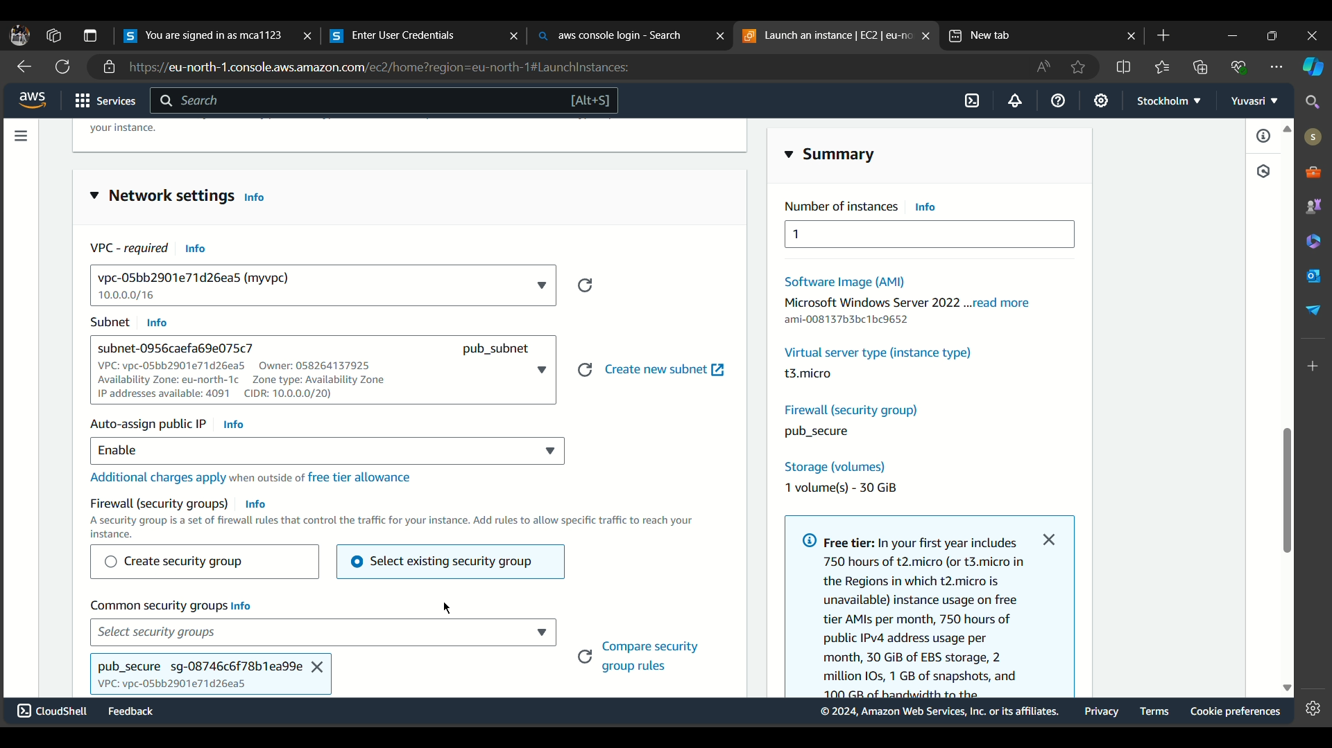

**Step 2:** In the private instance creation edit “Network settings” and choose our VPC and select private subnet and disable the auto assign IP address and select existing security group and click private security group and click launch instances.

**5) Enable internet access for the public instances and configure a NAT gateway to provide internet access to the private instances.**

**Step 1:** Click “Launch instance” of the public instance

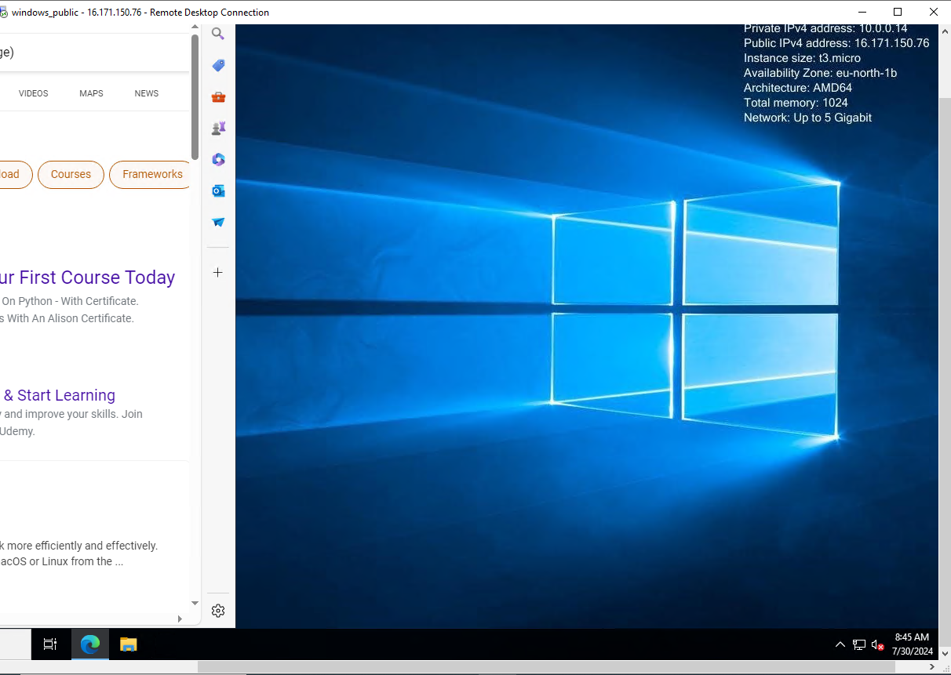

**Step 2:** In the public instances go to run command and type “mstsc” command a remote desktop connection window is opened. In that window give Private IP address of the private instances and credentials is opened in that credentials give password and username.

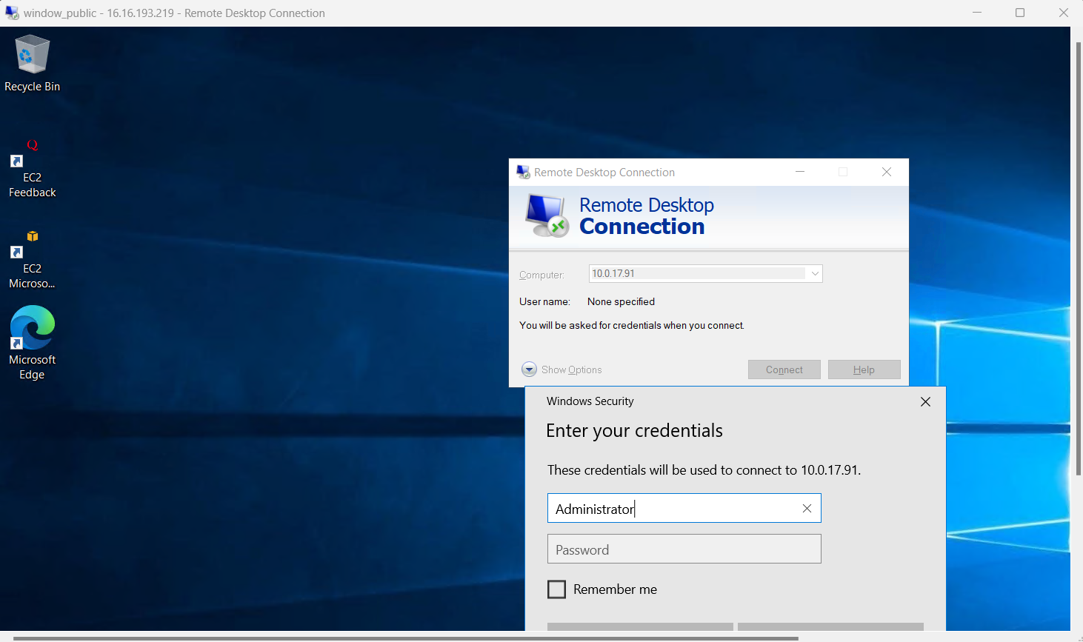

**Step 3:** In the private instance there is no network provision is given. So create NAT gateway to provide internet via the public instances.

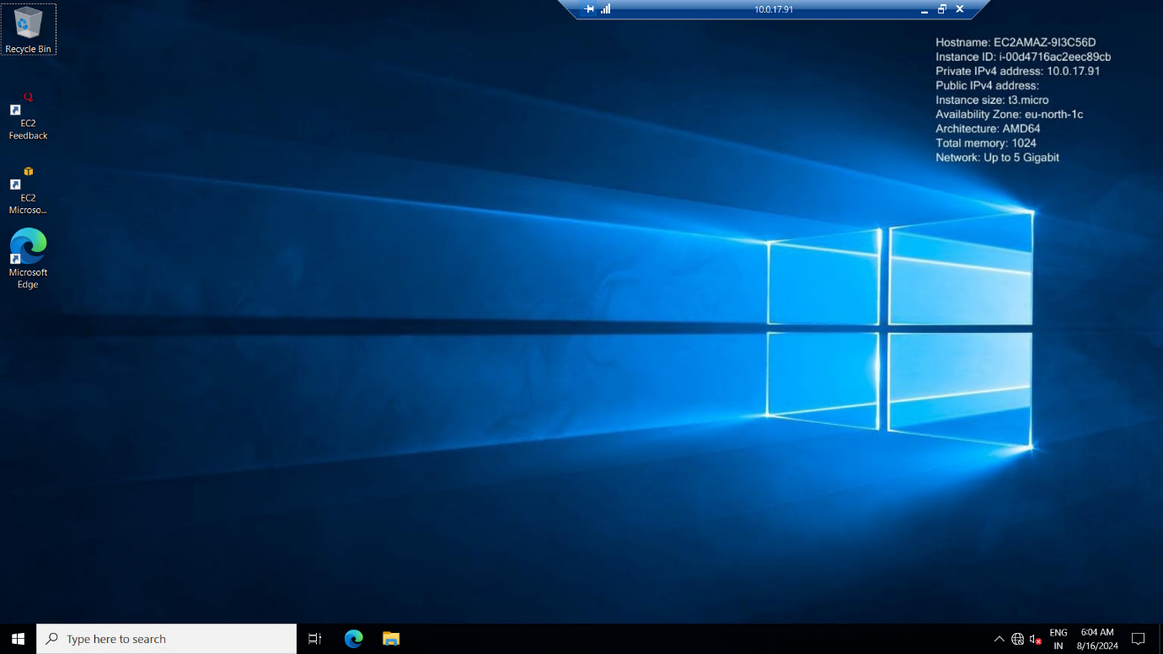

**Step 4:** Go to create NAT Gateway .Give name of the NAT gateway and select public subnet ,connectivity type is “Public” and click “Allocate Elatic IP” and click “Create NAT Gateway”

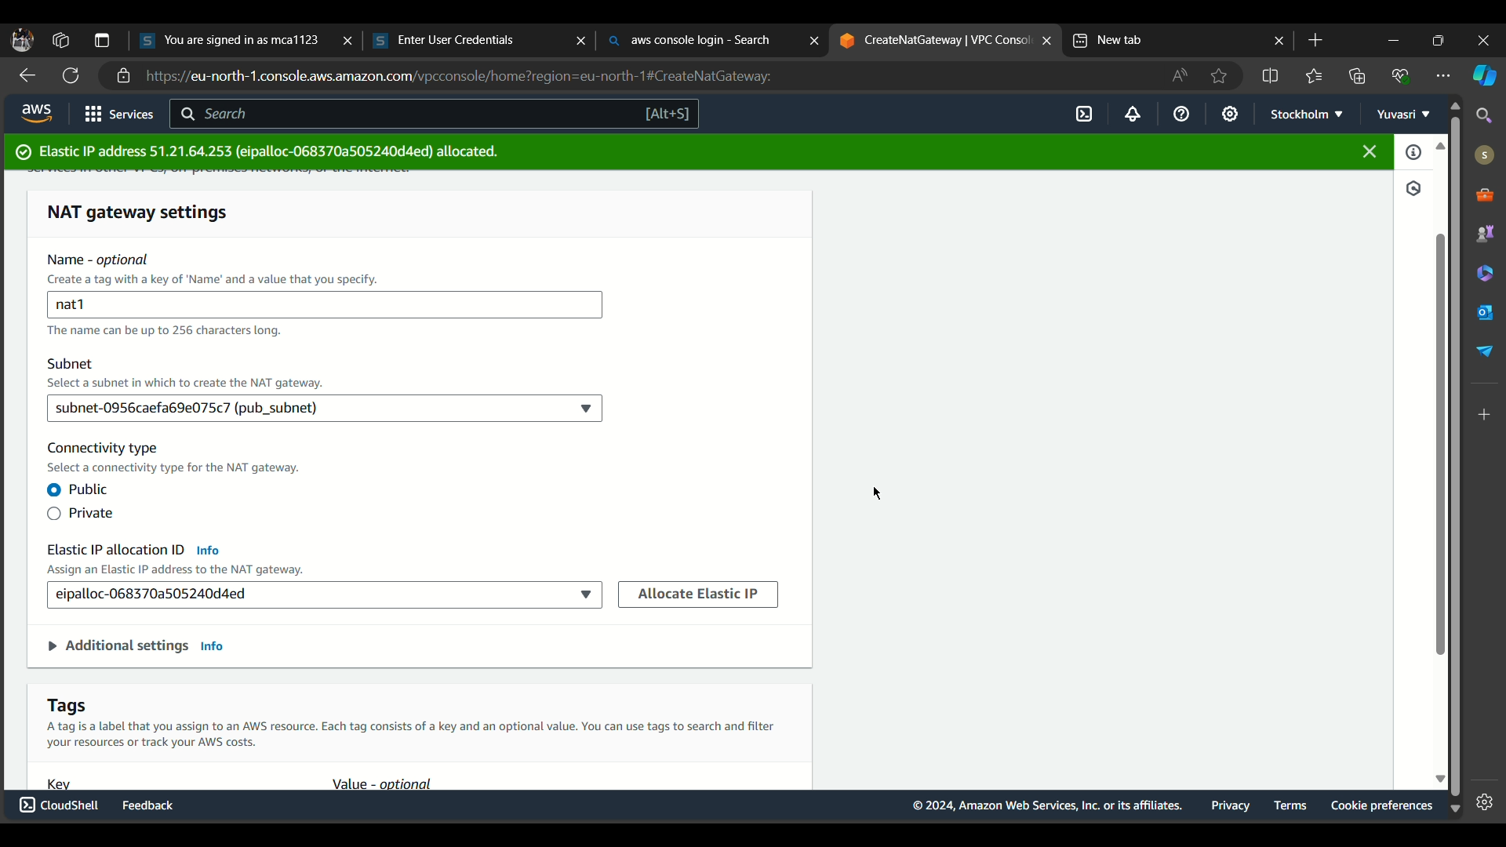

**Step 5:** After creating NAT gateway go to private route table and click “Edit Route” and select “NAT gateway” and save changes.

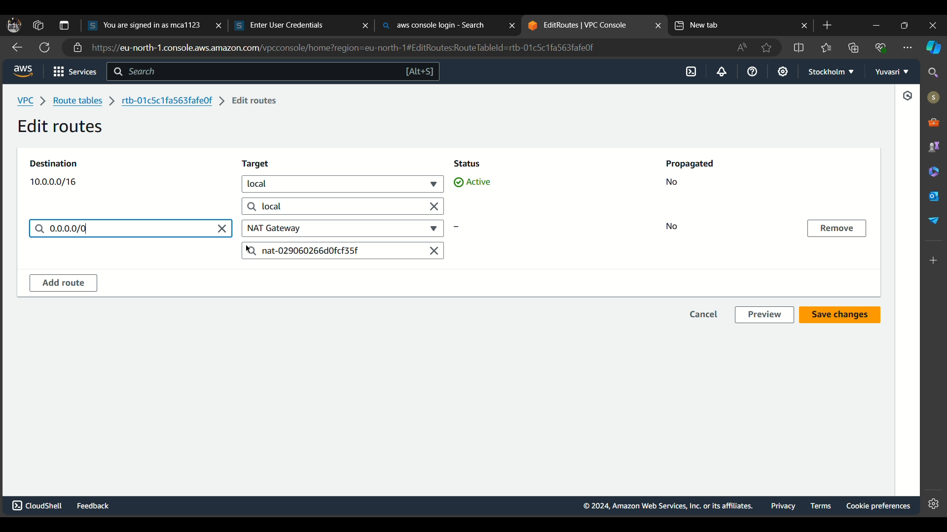

**Step 6:** Click “Launch instances” of the public instances. And connect remote connection for the private instances and the internet connection is provided for the private instances.

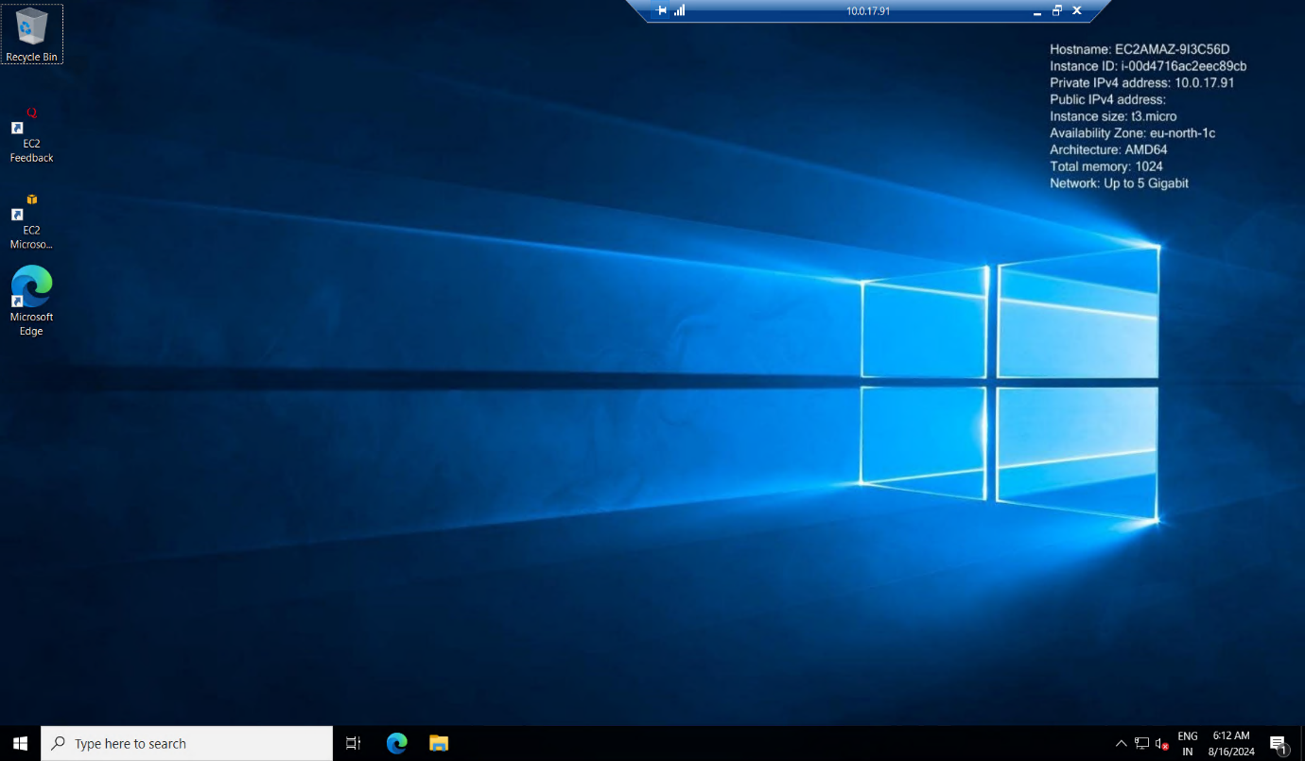

**CONCLUSION:**

Thus the above steps for creating a virtual private cloud(VPC) and provide internet provision for both public and private instances was executed successfully.